EDA
Exploratory Data Analysis (EDA)

The dataset employed in this study is the HR Analytics Dataset from Kaggle (Xokent, 2023), comprising 1,470 employee-level observations and 35 attributes that describe professional and demographic characteristics.
Variables include:
- Personal demographics (age, gender, marital status, and education)
- Occupational attributes (department, job role, job level, monthly income, and total working years)
- Attitudinal measures related to job satisfaction, performance, and work–life balance.
We believe that the target variable is Attrition. According to dataset dictionary, it indicates whether an employee has left the organization.
The exploratory analysis was performed in Python using pandas, matplotlib, and seaborn to reveal patterns that may have ethical or fairness implications when building predictive models for employee attrition and promotion.

1. Workforce Demographics

Figure 1 (Gender Distribution) shows a modest gender imbalance, with approximately 60 percent male and 40 percent female employees. Although this mirrors certain industry realities, such disproportionality can introduce bias if gender or correlated variables (e.g., job role or income) influence model predictions. Fairness auditing will therefore need to account for representation equity.

Figures 2 and 3 (Age Distribution and Age Group Distribution) reveal a right-skewed profile: most employees fall between 30 and 40 years old, with relatively few under 25 or over 55. The limited presence of younger and older workers means any model trained on these data could generalize poorly to early-career hires or late-career employees. This distribution also suggests that workplace retention policies may be most impactful for mid-career professionals, who dominate the dataset.

Figure 1 – Gender Distribution
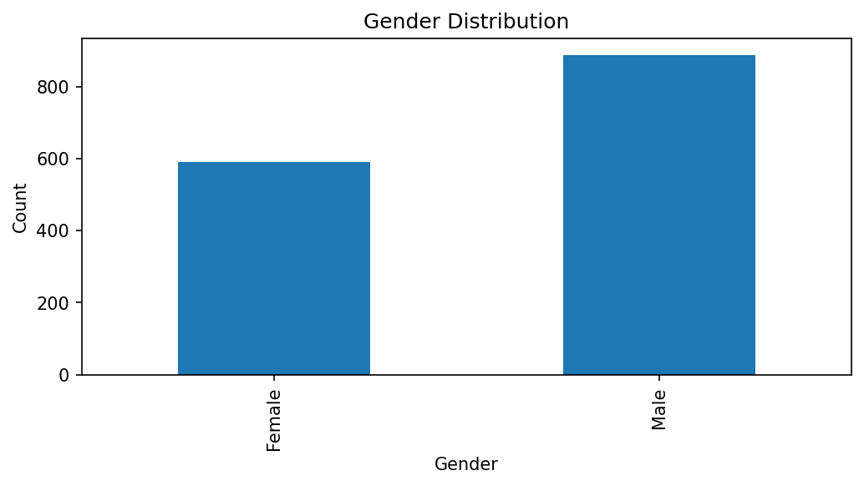

Figure 2 – Age Histogram
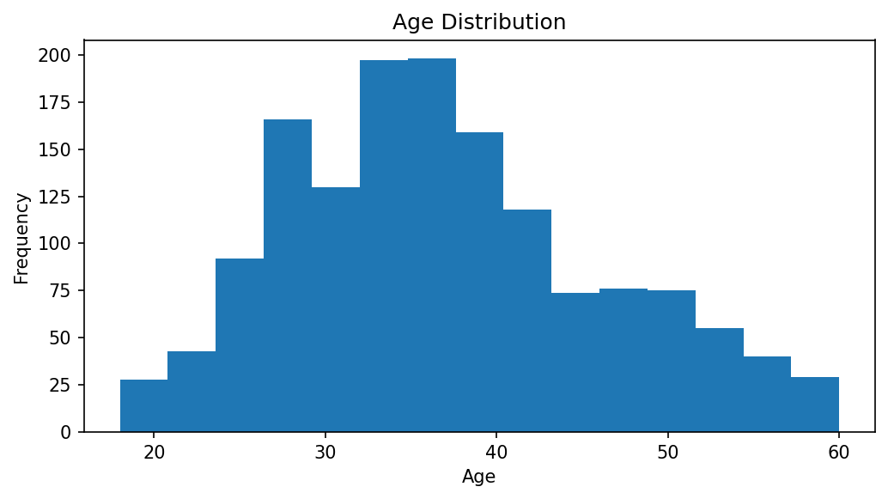
Figure 3 – Age Group Distribution
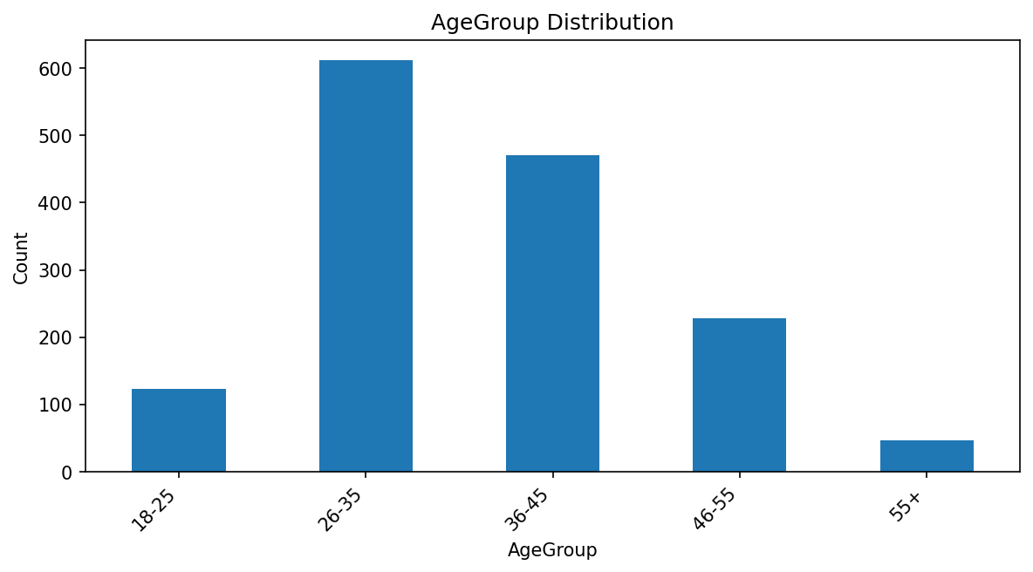
2. Departmental and Occupational Structure

Figure 4 (Department Distribution) demonstrates that most employees work in Research & Development, followed by Sales and Human Resources. The structural imbalance across departments implies that model outcomes will be more statistically reliable for R&D than for smaller groups such as HR. From an ethical perspective, it is essential to test whether employees in less-represented departments experience systematic differences in predicted attrition risk or promotion likelihood.

Compensation-related attributes reveal additional disparities. Figure 11 (Monthly Income by Gender) shows that male employees receive slightly higher 75th percentile monthly income than female employees. Figure 12 (Monthly Income by Gender within Job Level) further illustrates that this disparity persists even after controlling for job level: within each hierarchical tier, male employees’ earnings tend to remain above female counterparts’. This indicates that historical pay inequities may be embedded in the data, creating potential proxy bias if income or job level variables are directly included in predictive models. Debiasing techniques or fairness-constrained optimization may therefore be necessary to mitigate gender-linked income effects.

Figure 4 – Department Distribution
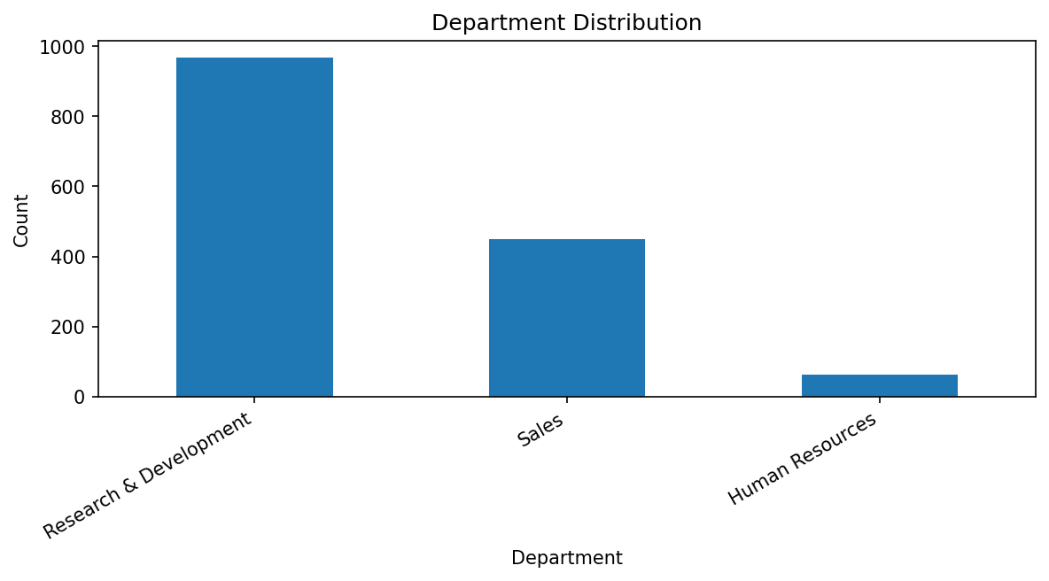
Figure 11 – Monthly Income by Gender
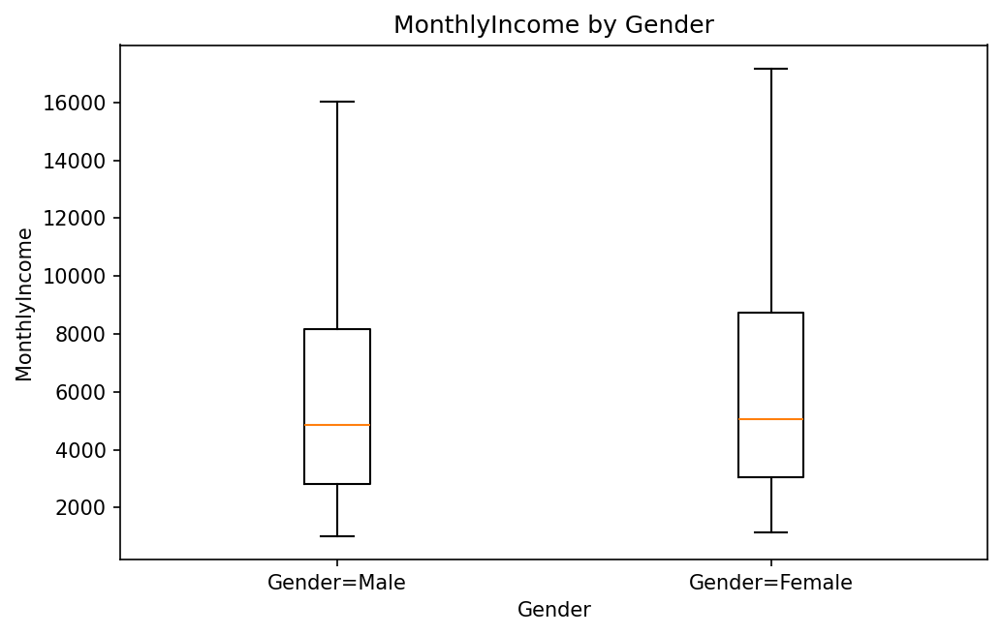
Figure 12 – Monthly Income by Gender within Job Level
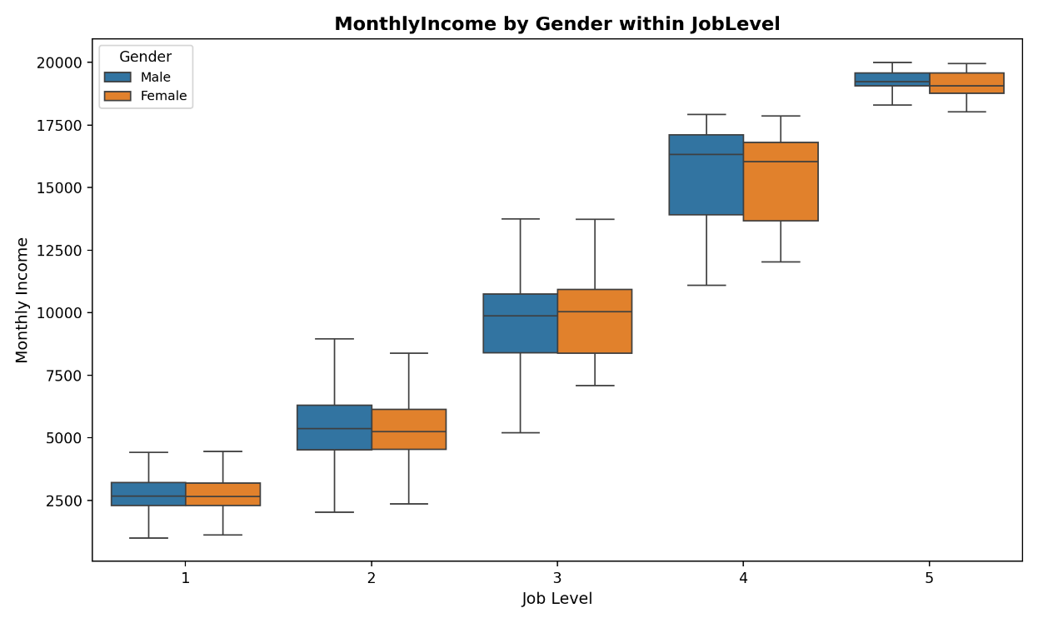

3. Attrition Patterns

Figure 5 (Attrition Distribution) confirms that attrition is relatively infrequent—roughly 16 percent of employees have left—creating a substantial class imbalance. Without correction, machine-learning models will overpredict employee retention, reducing fairness for minority outcomes. Techniques such as stratified sampling, cost-sensitive learning, or resampling will help maintain predictive parity between classes.

Figures 6 through 9 explore demographic and behavioral correlates of attrition. Figure 6 (Attrition Rate by Gender) shows that male employees exhibit marginally higher attrition rates, possibly reflecting greater mobility or occupational stress. Figure 7 (Attrition Rate by Education Level) indicates that workers with lower educational attainment face slightly higher attrition probabilities, though the pattern is weak. Figure 8 (Attrition Rate by Age Group) demonstrates a strong negative relationship between age and attrition: younger employees (20–29) are the most likely to leave, and the rate declines steadily with age. Finally, Figure 9 (Attrition Rate by Overtime Status) reveals a pronounced disparity—employees required to work overtime show significantly higher attrition likelihood.

Taken together, these results suggest that turnover is driven less by intrinsic qualifications and more by contextual and workload factors. They emphasize that fairness interventions should focus not only on algorithmic parity but also on organizational practices that differentially burden certain groups, particularly younger or overtime-assigned employees.

Figure 5 – Attrition Distribution
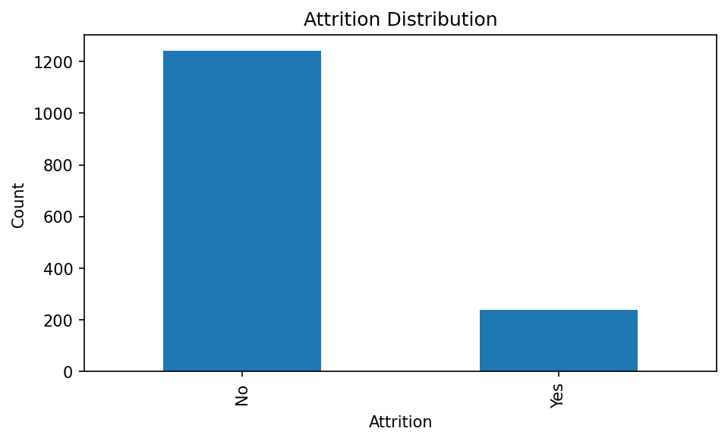
Figure 6 – Attrition Rate by Gender
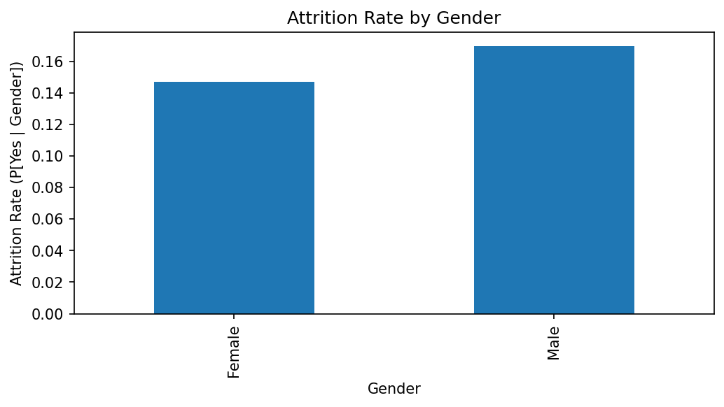
Figure 7 – Attrition Rate by Education Level
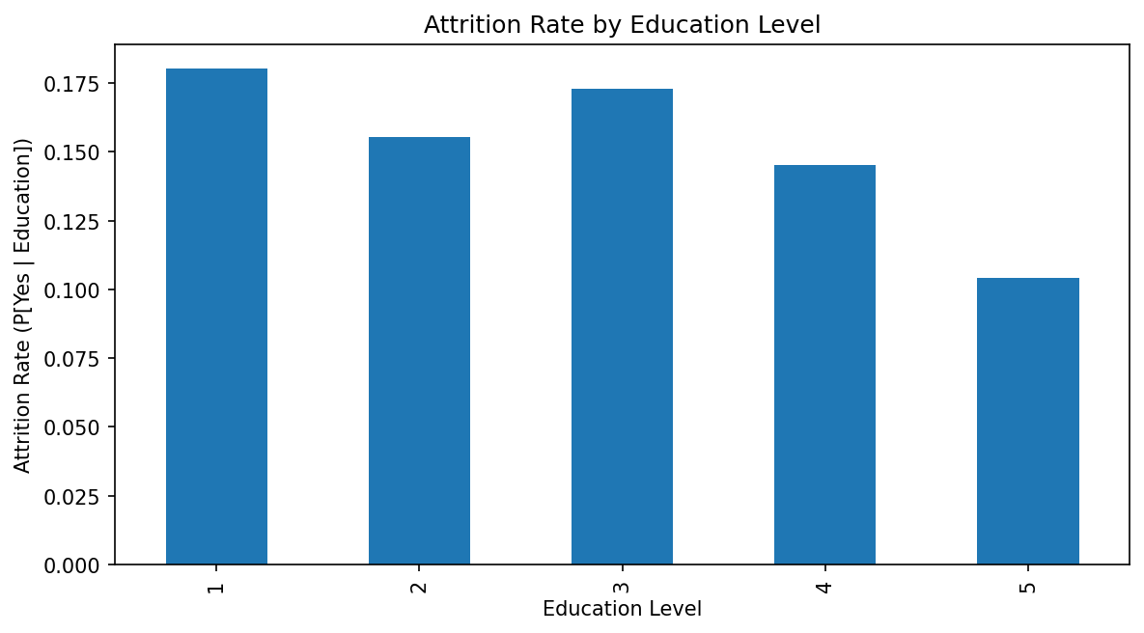
Figure 8 – Attrition Rate by Age Group
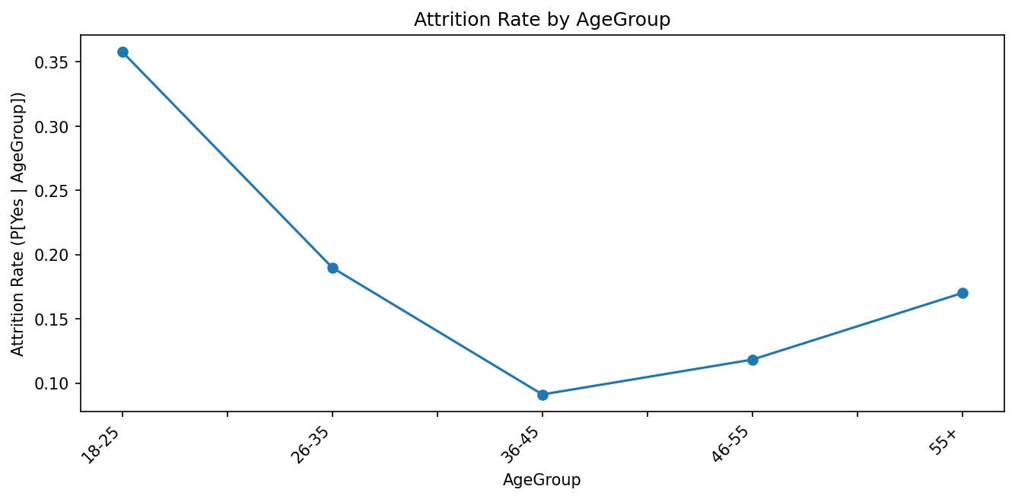
Figure 9 – Attrition Rate by Overtime Status
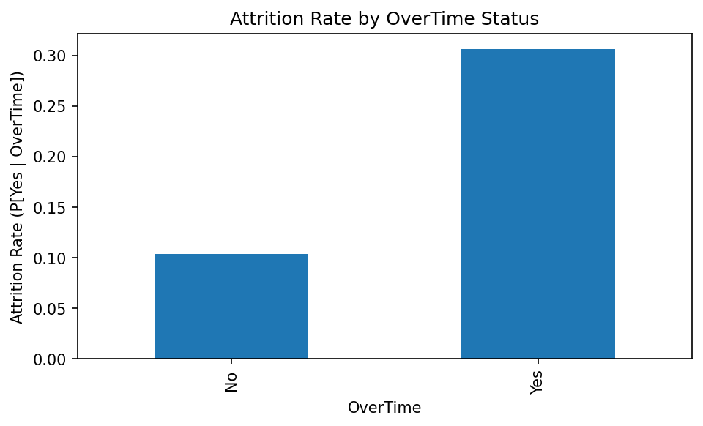
4. Job Satisfaction and Work–Life Balance Context

Although not visualized separately, descriptive statistics reveal that employees who left the organization tended to report lower work–life balance and job satisfaction scores than those who stayed. Median satisfaction levels for retained employees cluster near the top of the scale, whereas those who attrited more often rated their balance as moderate or poor. This reinforces the interpretation that retention decisions are intertwined with workplace well-being rather than solely demographic or performance variables. The result also underscores an ethical consideration: predictive systems should avoid framing attrition as a purely individual shortcoming when structural workload conditions contribute significantly to turnover.

5. Correlation Structure and Numerical Relationships

Figure 13 (Correlation Heatmap) summarizes pairwise relationships among numerical variables. Strong positive correlations appear between Monthly Income, Job Level, and Total Working Years, reflecting logical internal consistency—more senior employees earn higher pay and have accumulated more tenure. Weak positive correlation between Distance from Home and Attrition suggests that commuting burden slightly elevates turnover risk, while attitudinal metrics such as JobSatisfaction or RelationshipSatisfaction remain largely independent from financial measures.
Overall, we can observe that multicollinearity is limited. Therefore developing regression and classification won’t interfere with the interpretability for downstream modeling. Yet, fairness-critical attributes like Gender and Marital Status show indirect associations with Job Level and Income, meaning that models using these features risk encoding historical inequities. During later modeling phases, feature-importance analysis and fairness metrics (equal opportunity, demographic parity, predictive parity) will be applied to detect such indirect bias.

Figure 13 – Correlation Heatmap of Numeric Features
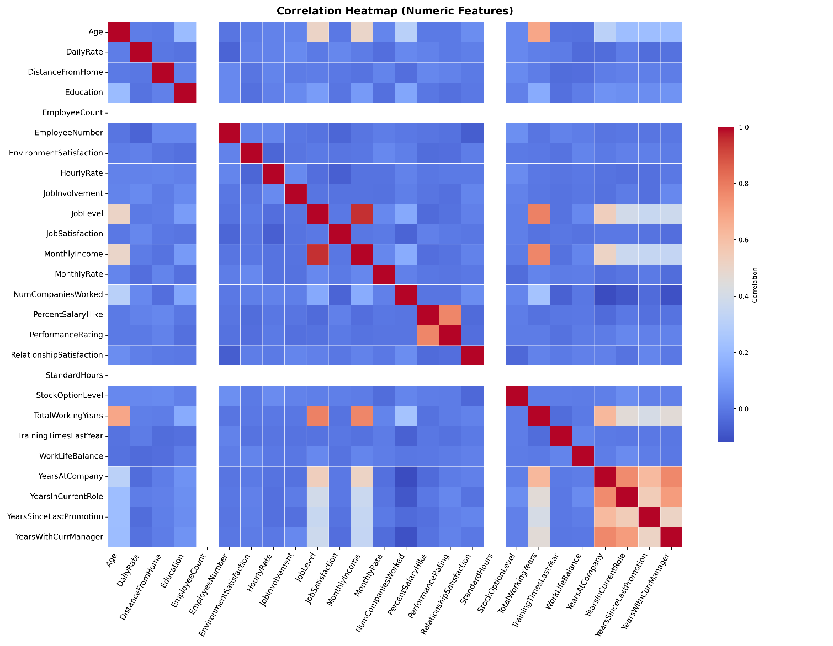

6. Ethical and Fairness Implications from EDA

The exploratory findings highlight several ethical dimensions relevant to the Fairness Layer of this project.
First, representational imbalance—both by gender and department—poses risk to fairness. Predictive models might reflect the majority group’s behavior more accurately, resulting in unequal error rates across demographic categories.
Second, evidence of income disparity by gender and hierarchical level suggests embedded structural inequities. If unaddressed, these relationships could violate equal-opportunity principles by privileging historically advantaged employees.
Third, workload intensity and work–life balance patterns underscore procedural fairness concerns within the organization: employees subjected to overtime demands experience systematically higher attrition, raising questions about justice beyond algorithmic fairness.
Overall, the quality of the dataset is sufficient. It presents both analytical richness and might identify substantial ethical challenges. Its multidimensional portrayal of human-resource patterns allows us to test fairness metrics in corporate context. The current imbalances illustrate the necessity of ethical data governance. The forthcoming modeling phase will build on these insights by constructing predictive pipelines. This way we can attempt to incorporate bias-mitigation strategies and rigorous fairness evaluation aligned with frameworks discussed in the paper.

